#Week 6

\*\* Task 1\*\* Considering the same example you solved in the previous assignment (radiative heat transfer between two parallel plates), how many shields with epsilon = 0.1 should you add in order to have the new heat transfer rate to be 1% of the case without shields ?

\*\* Task 2\*\* You should create a pdf file with screenshots of all of the steps we went through (clearly from your own file) and explain briefly the reason behind the use of each step (in your own words!)

$$ε=0.1$$

$$36.253=\frac{σ(T_{1}^{4}-T_{2}^{4})}{\left(\frac{1}{ε_{1}}+\frac{1}{ε_{2}}-1\right)-}$$

$${\dot{Q}}_{N shields= \frac{Aσ\left(T_{1}^{4}-T_{2}^{4}\right)}{\left(N+1\right)\left(\frac{1}{ε}+\frac{1}{ε}-1\right)}= \frac{1}{N+1}{\dot{Q}}_{no shields}}$$

1% of previous case $\dot{Q}$ = $\frac{1}{100}×3625.3\frac{W}{m^{2}}=36.253 W/{m^{2}}$

$$36.253\frac{W}{m^{2}}=\frac{5.67×{10}^{-8}×({800}^{4}-{500}^{4})}{(N+1)(\frac{1}{0.1}+\frac{1}{0.1}-1)}$$

$$36.253\frac{W}{m^{2}} =\frac{19680.57}{(N+1)(19)}$$

$N+1=$ 28.57

N=27.57 $\sim 28$

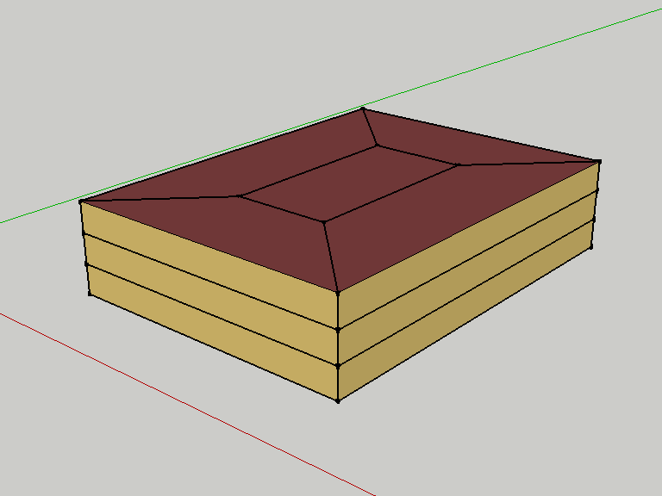Task 2

